RECRUITMENT & HIRING
ANALYTICS REPORT
Full-Year Analysis of the Candidate Pipeline, Funnel Performance, Cost Efficiency and Quality of Hire
Reporting Period: January 2025 – July 2026
Dataset: HR_Recruitment_Hiring_Data.xlsx | 4,500 Candidate Records
Prepared for: Talent Acquisition & HR Leadership

Table of Contents
- 1. Executive Summary
- 2. Data Overview & Cleaning Notes
- 3. Recruitment Funnel Analysis
- 4. Recruitment Source & Cost Effectiveness
- 5. Departmental & Role Performance
- 6. Diversity & Candidate Demographics
- 7. Recruiter Performance
- 8. Quality of Hire
- 9. Compensation & Offer Analysis
- 10. Key Insights Summary
- 11. Recommendations

1. Executive Summary
This report analyses 4,500 candidate applications processed between January 2025 and July 2026 across 7 departments, 22 job roles and 8 UK office locations. The dataset tracks each candidate end-to-end — from application through screening, interviews, assessment, offer and (where applicable) joining and probation — enabling a full view of pipeline health, cost efficiency and hiring quality.

4,500  Total Applications | 975  Total Hires | 21.7%  Overall Conversion | 52.7  Avg. Days to Hire

70.9%  Offer Acceptance Rate | £2.39M  Total Hiring Cost | £2,452  Cost per Hire | 77.1%  Probation Pass Rate

Headline Findings
- Only 21.7% of applicants are ultimately hired; the two largest drop-off points are Screening (32.6% rejected) and the Interview/Assessment stage (40.3% of interviewed candidates rejected).
- Employee Referrals and the Company Careers Page deliver the lowest cost per hire (£2,394 and £1,622 respectively), while Recruitment Agencies cost more than double the referral channel (£4,885 per hire) despite a similar conversion rate.
- Compensation is the single most decisive factor in offer decline: declined offers were on average £2,564 below candidate expectations, while accepted offers were on average £274 above expectations.
- 13.3% of new hires do not pass probation, indicating a quality-of-hire gap worth investigating alongside interview scoring calibration.
- Hiring pace is consistent across departments (51–54 days average), suggesting the 52.7-day average time-to-hire is a structural process characteristic rather than a departmental issue.

2. Data Overview & Cleaning Notes

2.1 Dataset Structure
The source file contains a single table of 4,500 rows and 28 columns, one row per candidate application. Key field groups:
- Candidate & Requisition identifiers: Candidate_ID, Requisition_ID
- Application details: Application_Date, Department, Job_Role, Location, Recruitment_Source, Recruiter
- Candidate profile: Gender, Age, Experience_Years, Education_Level, Expected_Salary_GBP
- Pipeline stage data: Screening_Result, Interview_1_Date/Score, Assessment_Score, Interview_2_Date/Score
- Outcome data: Offer_Status, Offer_Date, Offered_Salary_GBP, Candidate_Status, Joining_Date, Days_to_Hire, Hiring_Cost_GBP, Offer_Decline_Reason, Probation_Status

2.2 Data Quality Assessment
The dataset was checked for duplicates, invalid values, logical inconsistencies and missing data before analysis. Results:
Check | Result
Duplicate Candidate_ID records | None found (4,500 unique)
Negative or invalid Days_to_Hire / Hiring_Cost | None found
Days_to_Hire vs. (Joining_Date − Application_Date) | Fully consistent for all 975 hires
Candidate_Status counts vs. funnel stage counts | Fully reconciled (sums match exactly)
Text fields (Department, Source, etc.) | Standardised for whitespace; casing already consistent

2.3 Handling of Missing Values
Missing values in this dataset are structural, not data-quality errors — they reflect a candidate's natural exit point in the funnel. For example, a candidate rejected at screening will never have an Interview_1_Date, Offer_Date or Joining_Date. These were intentionally left blank (not imputed or dropped) so that funnel-stage counts remain accurate:
Field | Non-Null Count | Reason for Missingness
Interview_1_Date / Score, Assessment_Score | 3,033 / 4,500 | Not reached by candidates rejected at screening
Interview_2_Date / Score | 1,811 / 4,500 | Not reached by candidates rejected after Interview 1 / assessment
Offer_Date, Offered_Salary_GBP | 1,375 / 4,500 | Only populated once an offer is extended
Joining_Date, Days_to_Hire, Probation_Status | 975 / 4,500 | Only populated for candidates who were hired
Offer_Decline_Reason | 400 / 4,500 | Only populated when a candidate declines an offer

2.4 Derived Fields Added for Analysis
- Application_Month / Application_Quarter – for trend analysis
- Salary_Gap_GBP (Offered − Expected Salary) – for compensation analysis
- Stage-reached flags (Passed_Screening, Reached_Interview1, Reached_Interview2, Is_Offer_Extended, Is_Hired, Is_Offer_Declined) – to build the funnel and conversion-rate calculations powering the dashboard

3. Recruitment Funnel Analysis
The recruitment process consists of six stages. The chart below shows the volume of candidates remaining at each stage.
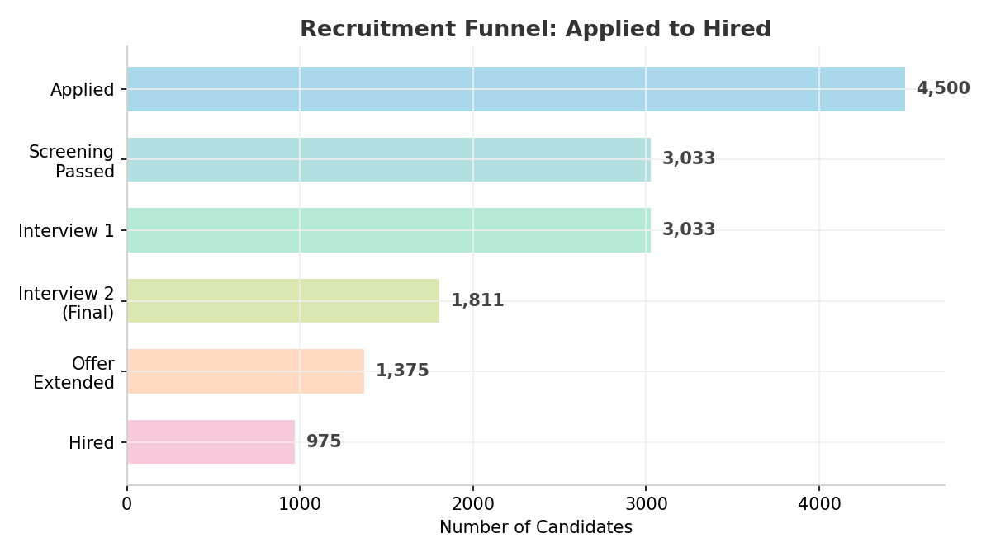
Figure 1: Recruitment funnel from application to hire

3.1 Stage-by-Stage Conversion
Stage | Candidates | % of Previous Stage | % of Total Applied
Applied | 4,500 | — | 100.0%
Screening Passed | 3,033 | 67.4% | 67.4%
Interview 1 Completed | 3,033 | 100.0% | 67.4%
Interview 2 (Final) Completed | 1,811 | 59.7% | 40.2%
Offer Extended | 1,375 | 75.9% | 30.6%
Hired (Offer Accepted) | 975 | 70.9% | 21.7%

3.2 Where Candidates Are Lost
- Screening (32.6% loss): 1,467 of 4,500 applicants are rejected at screening — the single largest drop-off point in the funnel, ahead of even the interview stages.
- Interview / Assessment (40.3% loss): Of the 3,033 candidates who reach interview stage, 1,222 are rejected before a final interview is scheduled — the second-largest loss point.
- Final Interview (24.1% loss): 436 of 1,811 candidates who reach the final interview are not offered a role.
- Offer Stage (29.1% loss): 400 of 1,375 extended offers are declined by the candidate — a controllable loss point tied closely to compensation (see Section 9).

4. Recruitment Source & Cost Effectiveness
Seven recruitment sources feed the pipeline. Effectiveness is measured on two dimensions: conversion rate (Applied → Hired) and cost per hire.
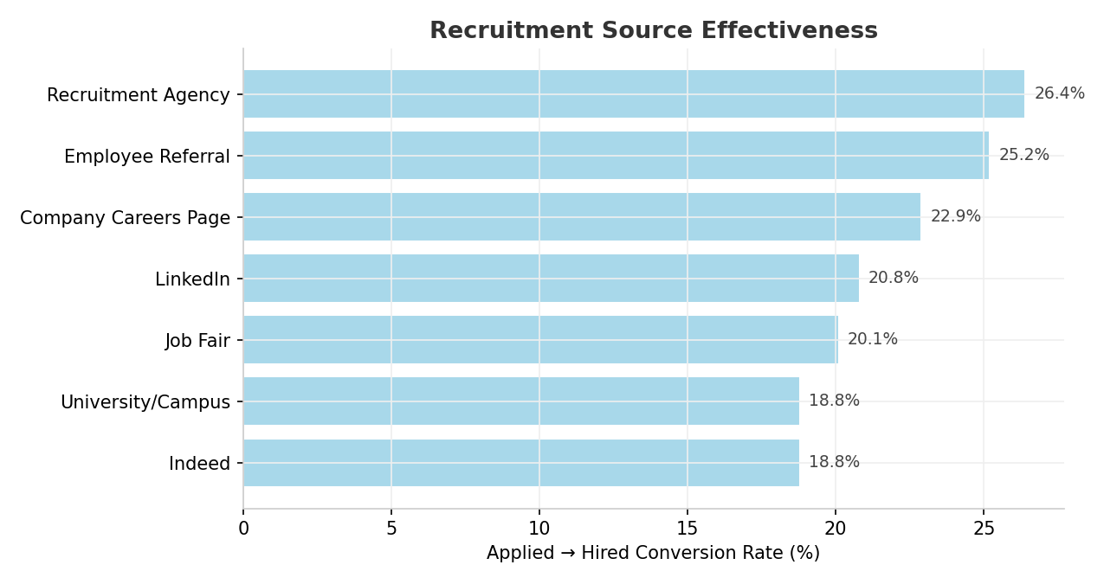
Figure 2: Conversion rate by recruitment source
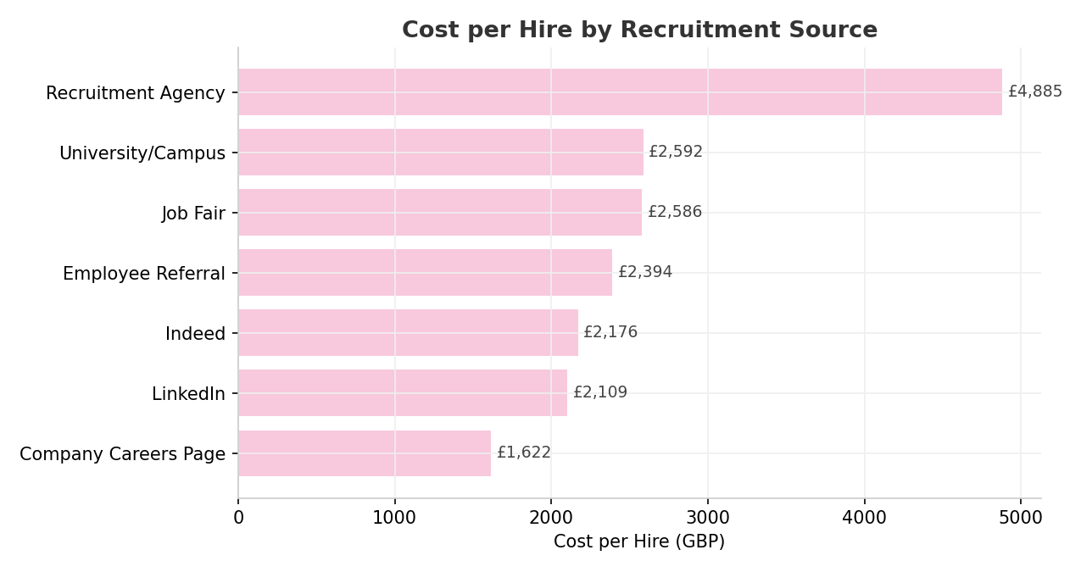
Figure 3: Cost per hire by recruitment source
Source | Applied | Hired | Conv. Rate | Total Cost (£) | Cost / Hire (£)
Recruitment Agency | 420 | 111 | 26.4% | 542,239 | 4,885
Employee Referral | 624 | 157 | 25.2% | 375,910 | 2,394
Company Careers Page | 770 | 176 | 22.9% | 285,394 | 1,622
LinkedIn | 1,128 | 235 | 20.8% | 495,711 | 2,109
Job Fair | 264 | 53 | 20.1% | 137,060 | 2,586
Indeed | 964 | 181 | 18.8% | 393,795 | 2,176
University / Campus | 330 | 62 | 18.8% | 160,687 | 2,592

4.1 Observations
- Recruitment Agencies produce the highest conversion rate (26.4%) but at nearly 3x the cost per hire of the Company Careers Page — the least cost-efficient channel overall relative to quality of conversion.
- The Company Careers Page is the most cost-efficient channel (£1,622/hire) while still delivering an above-average 22.9% conversion rate, making it the best value channel in the mix.
- Employee Referrals combine a strong 25.2% conversion rate with the second-lowest cost per hire (£2,394), reflecting the well-documented advantage of referral hiring.
- LinkedIn drives the highest volume of applications (1,128) but converts below the channel average (20.8%), suggesting scope to tighten sourcing criteria or job-ad targeting on this platform.

5. Departmental & Role Performance
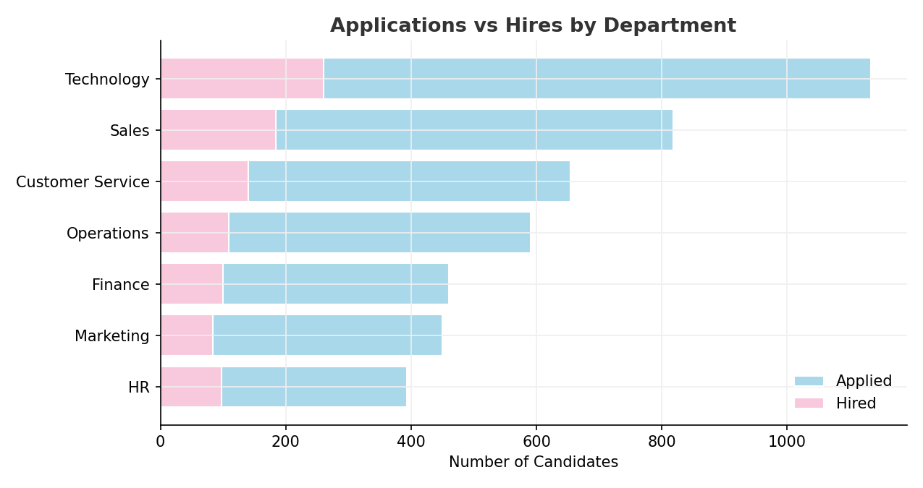
Figure 4: Applications vs. hires by department
Department | Applied | Hired | Conv. Rate | Avg. Days to Hire
Technology | 1,134 | 260 | 22.9% | 51.4
Sales | 818 | 184 | 22.5% | 54.1
Customer Service | 654 | 140 | 21.4% | 52.4
HR | 393 | 98 | 24.9% | 53.4
Finance | 460 | 100 | 21.7% | 51.9
Marketing | 450 | 84 | 18.7% | 53.8
Operations | 591 | 109 | 18.4% | 53.4

5.1 Observations
- Technology is both the largest hiring department (260 hires) and has one of the fastest average times-to-hire (51.4 days), suggesting an efficient, well-resourced process for technical roles.
- HR has the highest conversion rate of any department (24.9%), despite having the smallest applicant pool, indicating strong role/candidate fit at the top of its funnel.
- Operations and Marketing have the lowest conversion rates (18.4% and 18.7%) — worth reviewing job descriptions and screening criteria for these departments to reduce wasted recruiter effort.
- Average time-to-hire is remarkably stable across departments (51–54 days), indicating the 52.7-day company average is driven by shared process steps (e.g. two-stage interviews) rather than any single department's inefficiency.

6. Diversity & Candidate Demographics
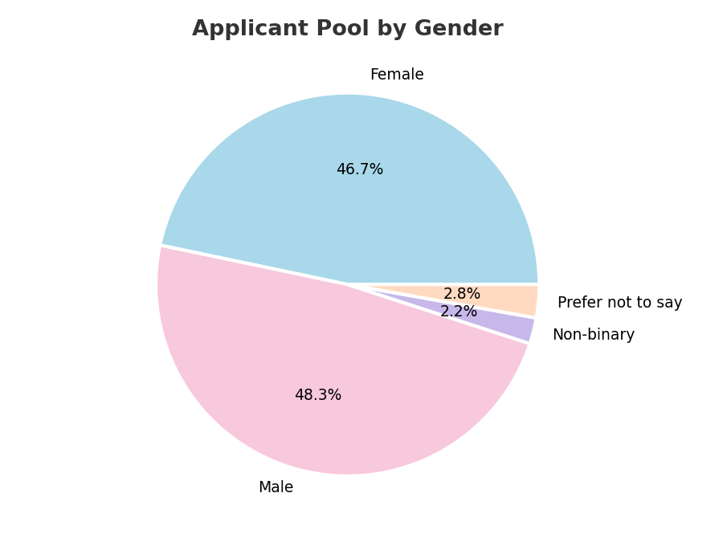
Figure 5: Applicant pool composition by gender
Gender | Applied | Hired | Conversion Rate
Female | 2,102 | 483 | 23.0%
Male | 2,173 | 456 | 21.0%
Non-binary | 99 | 18 | 18.2%
Prefer not to say | 126 | 18 | 14.3%

6.1 Education Level
Education Level | Applied | Hired | Conversion Rate
Professional Qualification | 236 | 59 | 25.0%
Master's | 956 | 212 | 22.2%
Bachelor's | 2,200 | 489 | 22.2%
Diploma | 674 | 139 | 20.6%
A-Level / Equivalent | 434 | 76 | 17.5%

6.2 Observations
- The applicant pool is close to gender-balanced (Female 46.7%, Male 48.3%), and female candidates convert at a slightly higher rate (23.0% vs 21.0% for male candidates).
- Candidates identifying as Non-binary or 'Prefer not to say' convert at meaningfully lower rates (18.2% and 14.3%) — a gap worth investigating to rule out unconscious bias at screening or interview stages.
- Higher education levels correlate with modestly higher conversion, but the gap between Bachelor's and Master's is negligible (22.2% both), suggesting the process does not over-index on postgraduate qualifications.

7. Recruiter Performance
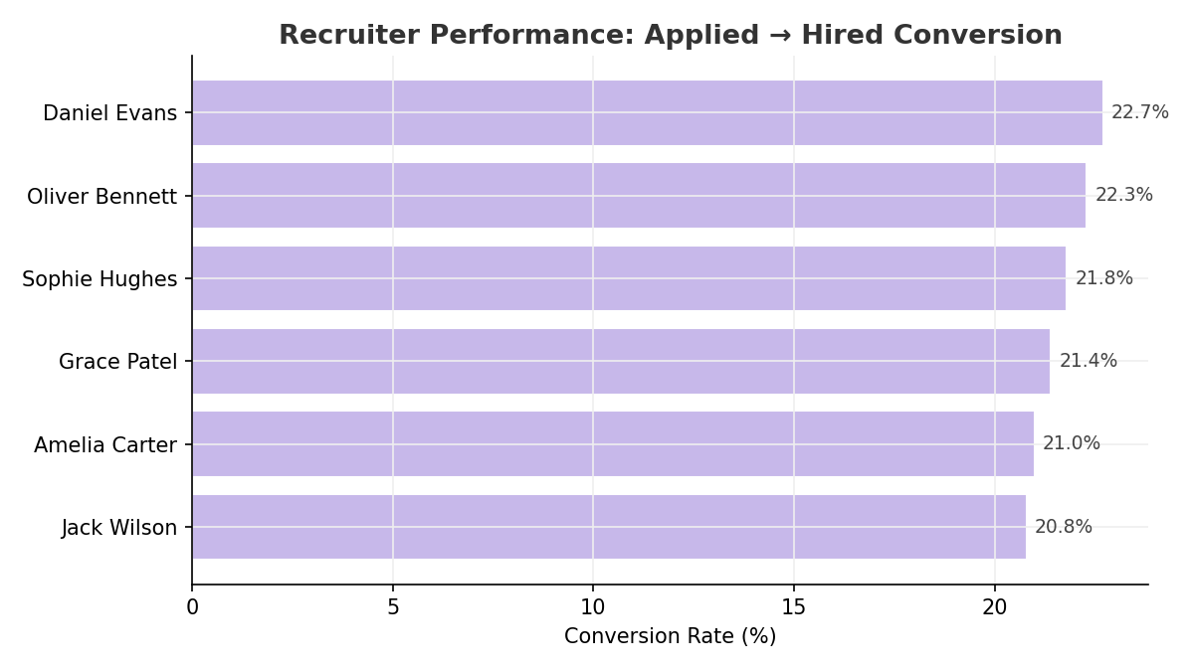
Figure 6: Recruiter conversion rate comparison
Recruiter | Applied | Hired | Conv. Rate | Avg. Days to Hire
Daniel Evans | 719 | 163 | 22.7% | 51.6
Oliver Bennett | 766 | 171 | 22.3% | 52.4
Sophie Hughes | 720 | 157 | 21.8% | 53.7
Grace Patel | 770 | 165 | 21.4% | 54.5
Amelia Carter | 765 | 161 | 21.0% | 51.9
Jack Wilson | 760 | 158 | 20.8% | 52.2

7.1 Observations
- Workload is evenly distributed across the six-person recruiting team (719–770 applications each), so performance differences reflect process/skill variation rather than volume imbalance.
- Daniel Evans leads on both conversion rate (22.7%) and speed (51.6 days), while Grace Patel has the slowest average time-to-hire (54.5 days) despite handling a similar caseload — a candidate for process-sharing or coaching.
- The spread between the highest and lowest performing recruiter is only 1.9 percentage points in conversion rate, indicating a reasonably consistent team rather than a single outlier issue.

8. Quality of Hire
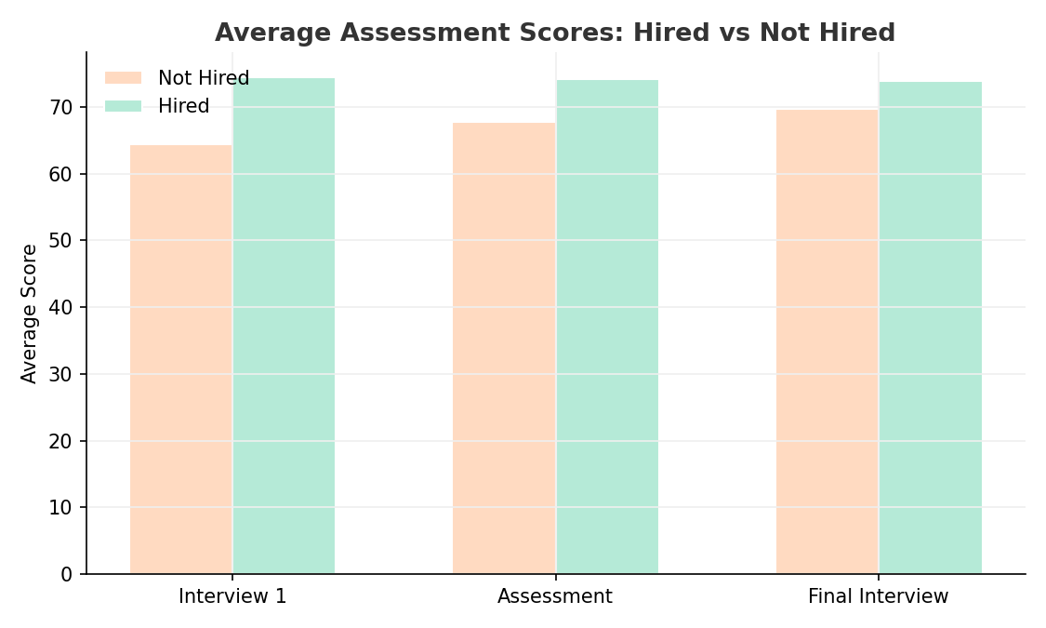
Figure 7: Average assessment scores — hired vs. not hired
Across all three evaluation checkpoints, hired candidates score consistently higher than those not hired: Interview 1 (74.5 vs 64.5), Assessment (74.2 vs 67.8) and Final Interview (73.9 vs 69.8). This confirms the scoring process is directionally predictive of hiring outcomes, though the gap narrows at the final interview stage, suggesting scoring calibration could be tightened at that step.
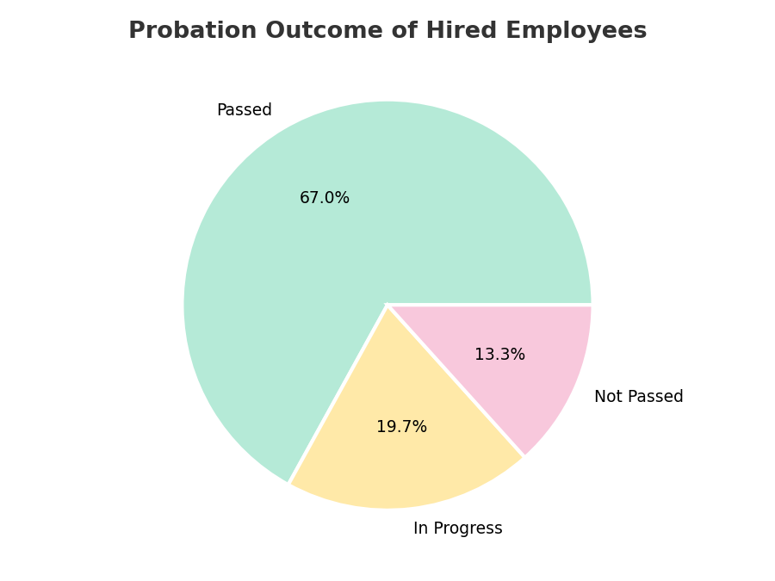
Figure 8: Probation outcome of hired employees (n = 975)

8.1 Observations
- 77.1% of hires (653 of 847 who have completed probation) pass successfully, but 13.3% overall (130 hires) do not pass probation — a meaningful quality-of-hire signal.
- 19.7% of hires (192) are still in progress on probation at the time of this data extract.
- Because final-interview score gaps between hired and not-hired candidates are the narrowest of the three checkpoints, some 'borderline' hires may be entering the pipeline — worth cross-referencing final interview scores against probation outcomes for hires below a defined threshold.

9. Compensation & Offer Analysis
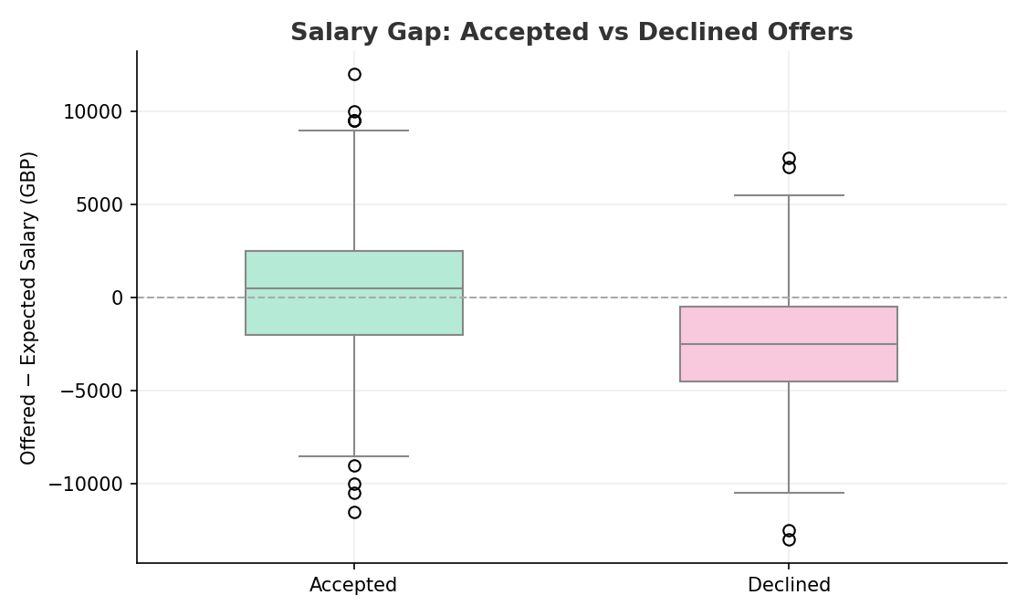
Figure 9: Salary gap (Offered − Expected) for accepted vs. declined offers
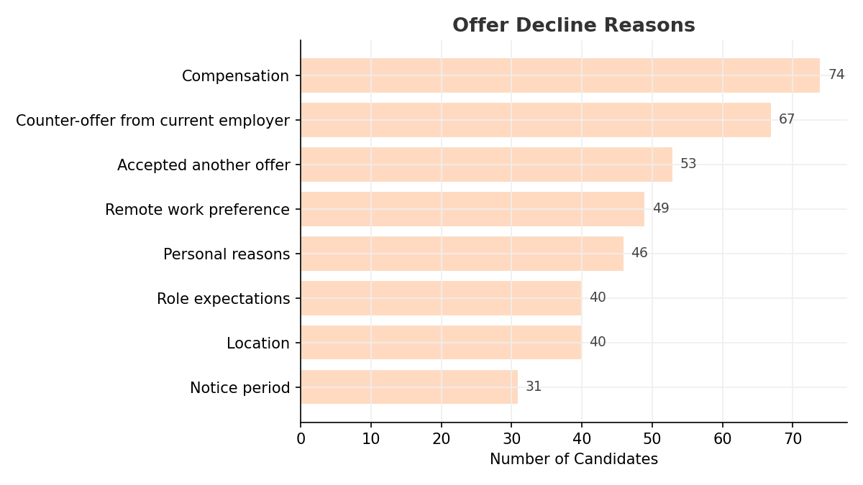
Figure 10: Stated reasons for declining an offer (n = 400)

9.1 Observations
- Offers that were accepted carried an average salary gap of +£274 (offered slightly above expectation); offers that were declined carried an average gap of −£2,564 (offered notably below expectation) — the clearest quantifiable driver of decline in the dataset.
- Compensation (74 candidates) and counter-offers from the current employer (67 candidates) are the two leading stated reasons for decline, together accounting for over one-third of all declines.
- Remote work preference (49) and location (40) combined account for 22% of declines, pointing to flexibility and site-location expectations as a secondary but material factor.

10. Key Insights Summary
Pipeline Health
- Only 1 in 5 applicants (21.7%) is ultimately hired; screening and interview/assessment stages account for the largest volume losses.
- Average time-to-hire of 52.7 days is consistent across departments and recruiters, indicating a structural (process-level) rather than team-level driver.
Cost Efficiency
- Cost per hire varies nearly 3x across sourcing channels (£1,622–£4,885); the Company Careers Page and Employee Referrals are the most cost-efficient at scale.
- Total hiring spend of £2.39M across the period averages £2,452 per hire once all sourced, screened and interviewed candidates are factored in.
Offer & Compensation
- 29.1% of extended offers are declined; the average pay gap between accepted and declined offers (£274 vs −£2,564) makes compensation the most quantifiable, actionable lever for improving offer acceptance.
Quality & Diversity
- Assessment and interview scores are directionally predictive of hiring outcomes, but 13.3% of hires still fail probation — suggesting room to tighten the predictive power of final-stage evaluation.
- The applicant pool is broadly gender-balanced, but candidates identifying as Non-binary or preferring not to disclose gender convert at visibly lower rates and warrant a closer equity review.

11. Recommendations
1. Rebalance sourcing spend toward the Company Careers Page and Employee Referrals
- Recommendation: Shift a portion of Recruitment Agency spend toward growing the Careers Page and a formal Employee Referral incentive programme.
- Why: These two channels combine above-average conversion (22.9% and 25.2%) with the lowest cost per hire (£1,622 and £2,394) — Agency hires cost 2–3x more for a similar or only marginally better conversion rate (26.4%).

2. Introduce a compensation-band check before extending offers
- Recommendation: Cross-reference each candidate's Expected_Salary against the proposed Offered_Salary before the offer is issued, and flag offers more than ~£1,000 below expectation for review.
- Why: Declined offers average £2,564 below candidate expectations, versus +£274 for accepted offers. This is the single clearest, most actionable predictor of decline in the data and directly addresses 74 (18.5%) of the 400 declines attributed explicitly to compensation.

3. Tighten screening criteria to reduce early-stage attrition
- Recommendation: Review job descriptions and screening questions for Operations and Marketing roles, and for the two lowest-converting sources (Indeed, University/Campus), to pre-qualify candidates more precisely before screening.
- Why: Screening is the single largest drop-off point (32.6% of all applicants), and Operations/Marketing convert well below the company average (18.4–18.7%). Tighter upfront targeting reduces recruiter time spent on low-fit applicants without adding process steps.

4. Recalibrate final-interview scoring against probation outcomes
- Recommendation: Run a retrospective comparing Interview_2/Assessment scores of the 130 hires who failed probation against those who passed, and adjust scoring rubrics or pass thresholds accordingly.
- Why: The score gap between hired and not-hired candidates narrows most at the final interview stage (73.9 vs 69.8, the smallest gap of the three checkpoints), and 13.3% of hires still fail probation — indicating the final stage may be under-discriminating true fit.

5. Share Daniel Evans' and Amelia Carter's process practices across the recruiting team
- Recommendation: Pair the fastest (Daniel Evans, 51.6 days) and slowest (Grace Patel, 54.5 days) recruiters for a short process shadowing exercise, focused on scheduling cadence and candidate follow-up.
- Why: Workload is evenly distributed, so the ~3-day speed gap between recruiters reflects process technique rather than caseload — a low-cost, high-leverage improvement that could shave days off the company-wide 52.7-day average.

6. Investigate the lower conversion rate for Non-binary and undisclosed-gender candidates
- Recommendation: Conduct a structured equity review of screening and interview outcomes for these candidate groups, including anonymised comparison of scores at each stage.
- Why: These groups convert at 18.2% and 14.3% respectively, versus 21–23% for male and female candidates — a gap large enough to warrant investigation to rule out bias and protect both fairness and employer brand.

7. Set a target to reduce average time-to-hire below 45 days
- Recommendation: Map the current 52.7-day process end-to-end and identify where multi-day gaps occur between stages (e.g. screening-to-interview scheduling, interview-to-offer approval), then set stage-level SLAs.
- Why: Time-to-hire is consistent across departments and recruiters, meaning the delay is embedded in the shared process — a targeted SLA-based redesign is likely to benefit every department and recruiter simultaneously rather than requiring team-by-team fixes.

End of Report — generated from HR_Recruitment_Hiring_Data.xlsx (4,500 records, Jan 2025–Jul 2026).

